|  |  |  |  |  |
| --- | --- | --- | --- | --- |
| 1)Executive Summary | | | | |
| Project Manager | | Status Date | Phase | |
| *Michael C. Clough* | | 4/24/24 | 7 | |
| Project Status Schedule | Y | The demonstration of the completed vehicle went well and on schedule. | | |
| Green = Launch On Schedule | Yellow =Tasks Behind Schedule | | | Red = Critical Path Impact |
| Project Document Repository | https://github.com/sain4521/Project-SPYN | | | |

|  |  |  |  |  |
| --- | --- | --- | --- | --- |
| 2) Key Schedule Milestone Tracking from Gantt Chart | | | | |
| Milestone | Target Date | Actual Date | Status (%) | Comments |
| Demonstrate vehicle | 4/24/24 | 4/24/24 | 100 | The demonstration happened as expected. |
|  |  |  |  |  |
|  |  |  |  |  |
|  |  |  |  |  |
|  |  |  |  |  |
|  |  |  |  |  |
|  |  |  |  |  |
|  |  |  |  |  |
|  |  |  |  |  |

|  |
| --- |
| 3) Progress from This Week *<should include pending tasks from previous week>* |

* Demonstrated vehicle, the project is complete.

|  |
| --- |
| 4) Progress Planned for Next Week |

* The project is finished.

|  |
| --- |
| 5) Gantt Chart Updated *<add the newest Gantt Chart>* |

|  |  |  |  |  |  |  |  |  |  |  |  |  |  |  |  |  |  |  |  |  |  |  |  |  |  |  |  |  |  |  |
| --- | --- | --- | --- | --- | --- | --- | --- | --- | --- | --- | --- | --- | --- | --- | --- | --- | --- | --- | --- | --- | --- | --- | --- | --- | --- | --- | --- | --- | --- | --- |
|  | **26 Mar** | | | | | | **8**  **Apr** | | | | | | **15**  **Apr** | | | | | | **20**  **Apr** | | | | | | **24**  **Apr** | | | | | |
| code sensors |  |  |  |  |  |  |  |  |  |  |  |  |  |  |  |  |  |  |  |  |  |  |  |  |  |  |  |  |  |  |
| code autonomy for pickup/drop off |  |  |  |  |  |  |  |  |  |  |  |  |  |  |  |  |  |  |  |  |  |  |  |  |  |  |  |  |  |  |
| test pickup/drop off mechanism |  |  |  |  |  |  |  |  |  |  |  |  |  |  |  |  |  |  |  |  |  |  |  |  |  |  |  |  |  |  |
| code autonomy to car |  |  |  |  |  |  |  |  |  |  |  |  |  |  |  |  |  |  |  |  |  |  |  |  |  |  |  |  |  |  |
| test functionality of vehicle/fine tune |  |  |  |  |  |  |  |  |  |  |  |  |  |  |  |  |  |  |  |  |  |  |  |  |  |  |  |  |  |  |
| demonstrate vehicle |  |  |  |  |  |  |  |  |  |  |  |  |  |  |  |  |  |  |  |  |  |  |  |  |  |  |  |  |  |  |

|  |  |  |  |  |  |
| --- | --- | --- | --- | --- | --- |
| 6) Team-Evaluation for the Week | | | | | |
| Team Member Name | Absent | Poor | Fair | Good | Outstanding |
| Hossain Ahmed |  |  |  |  | x |
| Tongye Wu |  |  |  |  | x |
| Dhruval Aanadkar |  |  |  |  | x |
| Even Mehreteab |  |  |  |  | x |

**1. Description of Final Design:**

Our autonomous vehicle we designed for project Spyn drives itself through the maze using the right-

hand rule to navigate the maze. It has a small, compact design. It follows the wall to its right to visit

every area of the maze. We also included a wall bumping touch sensor to reorient the vehicle if it runs

into a wall. With our color sensor we can detect when the vehicle is over red, green, or blue. We also

included an ultrasonic sensor so the vehicle can detect how far walls are from it. We also included a

mechanism for picking up and dropping off the wheelchair bound passenger.

**2. Justification for Final Design:**

Next, we will explain why we designed the vehicle the way it is. We made it autonomous to meet the

demands of the project Spyn specifications. We included keyboard controls for manual control just in

case the vehicle runs into issues doing things itself. We implemented the right-hand rule for navigating

the maze to ensure the vehicle visits every area of the maze autonomously. We included the touch

sensor to have the vehicle reorient itself when it runs into walls to help better navigate the maze. The

color sensor was added to detect the colors red, blue, and green. We needed the vehicle to be able to

detect these colors so we could have it stop for 4 seconds at red, pick up the customer at blue, and drop

the customer off at green autonomously. The ultrasonic sensor was added to detect the vehicle’s

distance from walls, to better help navigate the maze. It will tell the vehicle if there is a wall to the right

or not. If there is no wall to its right, it goes right. If there is a wall to the right, it goes left. Lastly, we

added a mechanism for lifting the customer in their wheelchair to deliver them to their desired location.

It is also used to drop off the customer when it reaches the desired location.

**3. Demonstration Evaluation Form**

|  |  |
| --- | --- |
| **Item** | **Score** |
| Vehicle Quality | Sturdy |
| Vehicle Fits in a standard parking space. | Yes |
| Vehicle obeys traffic laws. | 3/3 |
| Vehicle reaches and detects pick up location. | Yes |
| Vehicle safely picks up passengers. | Yes |
| Passengers are safely secured in or on the vehicle. | Safe |
| Vehicle reaches and detects destination. | Yes |
| Passengers are safely secured in or on the vehicle. | Safe |
| Vehicle reaches and detects destination. | Yes |
| Passenger is safely dropped off | Yes |
| No human intervention is needed to complete navigation | None |
| Pick up process and Drop off process are autonomous | Neither, both remote |
| Total score | 100/100 |

4. **Pictures of Vehicle**

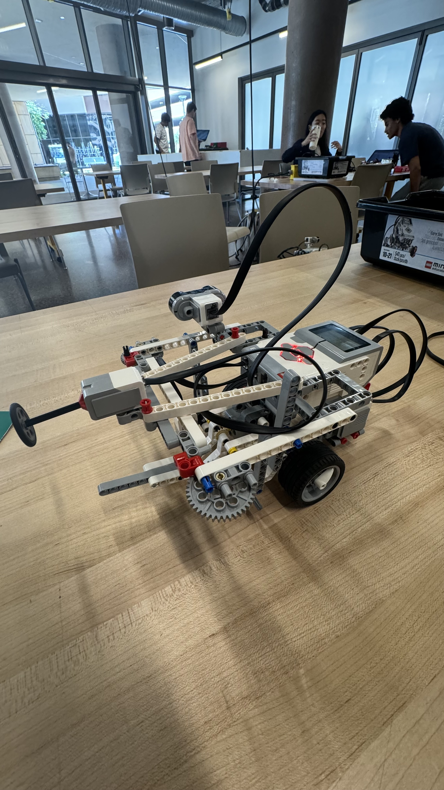 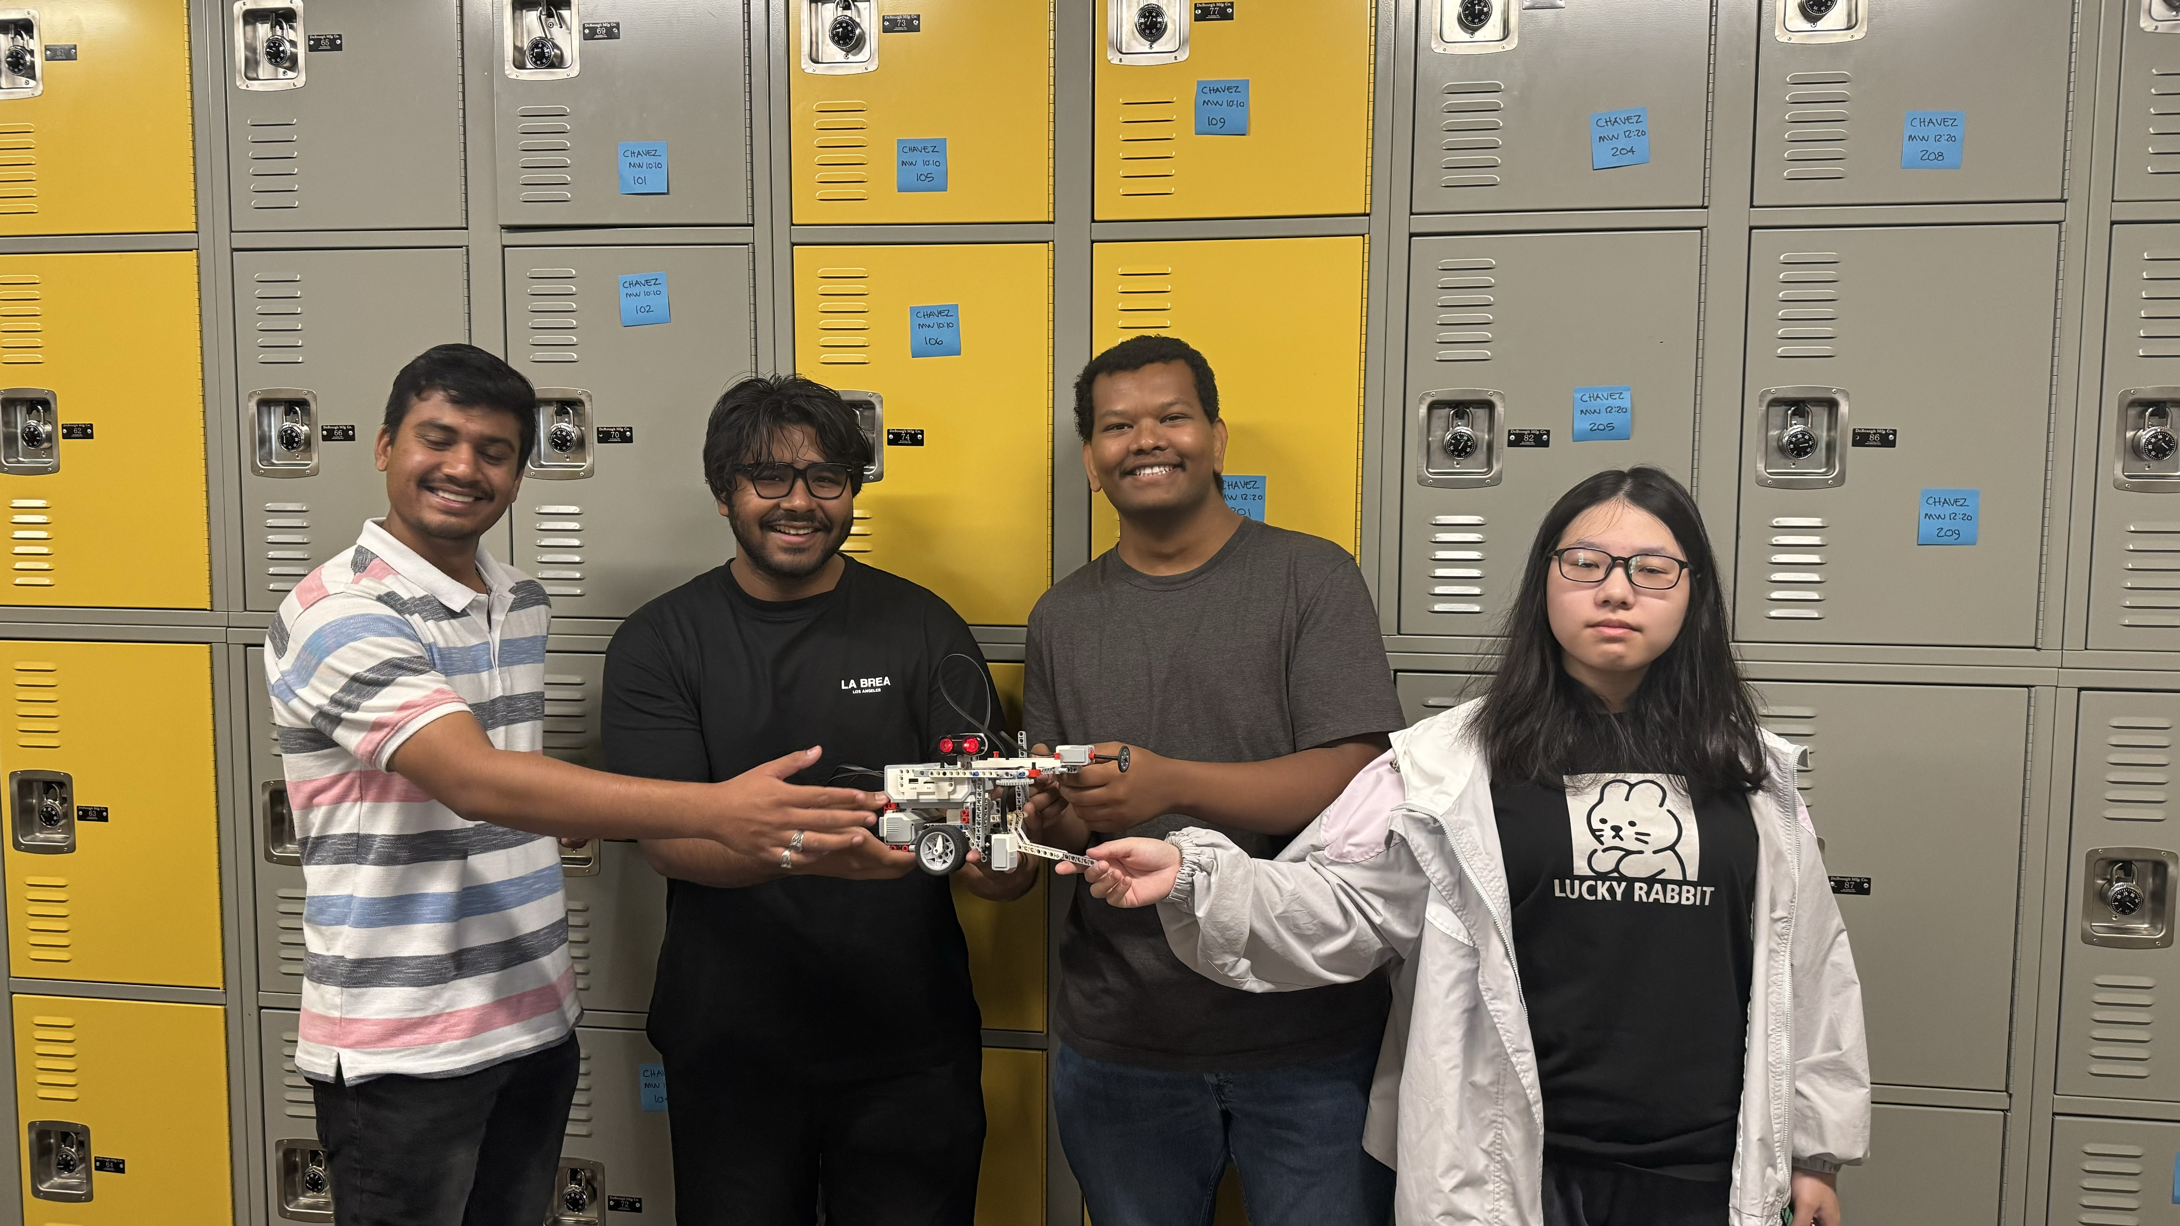 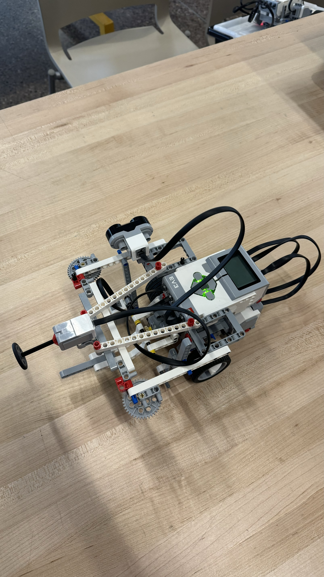 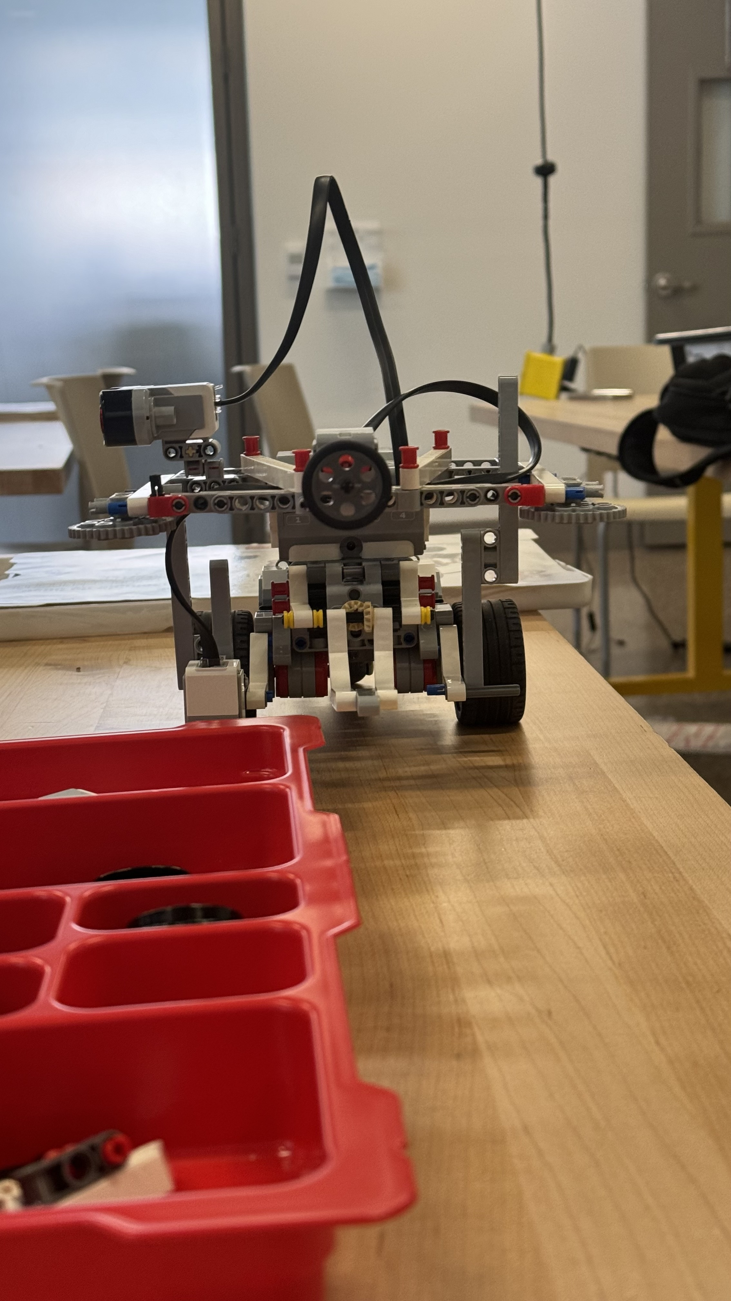

5. Project link: https://github.com/sain4521/Project-SPYN